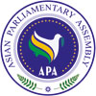

**Final Report**

**Standing Committee on Budget and Planning**

**3-5 September 2019**

**Baghdad, Republic of Iraq**

**SC-Budget and Planning /Rep/2019/04**

**4 September 2019**

The Standing Committee on Budget and Planning of Asian Parliamentary Assembly was held on 3-5 September 2019 in Baghdad, Republic of Iraq. Parliamentary delegations from following member countries participated in the meeting:

Afghanistan, Bahrain, Cambodia, Cyprus, India, Iran, Iraq, Jordan, Kuwait, Lebanon, Pakistan, Palestine, Russia, Saudi Arabia, Syria and Turkey. (Attachment I).

Advisory council member of Qatar and Arab Parliamentary Union attended the meeting as observer.

**Inaugural Ceremony:**

The following dignitaries presented their welcome statements and remarks at the opening session:

H.E. Mr. Serwan Abdullah Ismail, Secretary General of Iraqi Council of Representatives.

H.E. Mr. Muhammed Al Halbosi, Speaker of Iraqi Council of Representatives (Attachment II).

H.E. Mrs. Asuman Erdoğan, Representative of APA President.

H.E. Mr. Sherko Merwais, Chairman of Foreign Relations Committee, Iraqi Council of Representatives.

H.E. Dr. Mohammad Reza Majidi, APA Secretary General (Attachment III).

H.E. Mrs. Ala Al Talabani, Member of APA delegation of Iraqi Council of Representatives**,** Chairperson**.**

1. **Adoption of the Agenda:**

The Member Parliaments adopted the Draft Agenda of the Standing Committee on Budget and Planning. Agenda and Program of Work are attached (Attachment IV).

**2. Election of the Bureau:**

The following members of the Bureau were elected by acclamation:

* Chairperson: H.E. Mrs. Ala Al TALABANI, Head of APA delegation of Iraqi Council of Representatives, (on behalf of H.E. Mr. Rami Jabbar AL-SUKAINY).
* Vice Chairperson: H.E. Mr. Nicolaos TORNARITIS, Head of delegation of Cyprus.
* Rapporteur: H.E. Mr. Mutaz Abu RUMAN , Member of APA delegation of Jordan.

**3. Opening remarks by Chairperson:**

The chairperson presented her opening remarks.

**4. Report of Secretary-General:**

APA Secretary-General briefed the Standing Committee on the latest decisions and developments regarding the issues of planning budget of the APA Permanent Secretariat, under supervision of this Committee. He stated that we had a long journey from 2008, and I should appreciate the efforts and endeavours of all distinguished APA member parliaments who tried their best to promote the international status of the APA Permanent Secretariat by adopting the model of payment at the APA second Executive Council in Istanbul, 2018. APA Secretary General stated that: "The fact is, by implementation of this model of payment, the Secretariat could not even manage half of its Basic Budget and even if all active member parliaments pay their contribution based on the current adopted model of payment, the Secretariat hardly could survive. Therefore, I appeal to you to choose a pragmatic and constructive approach in your today’s deliberation". (Attachment V).

**5. Consideration and discussion on Draft Resolution:**

Under this agenda item, member countries engaged in a general debate about the APA Budget. The main topics were as follows:

* All participants expressed their special appreciation to Iraqi Council of Representatives for hosting this meeting in Baghdad and condolences were tribute to the demise of APA Representative of Palestine, Mr. Zuhair Sandoucka.
* Participants expressed their views on the equal annual payment of 20000 USD and that countries with less GDP should receive favorite status. Palestine, since it is under occupation should be totally exempted. (Russian Federation delegation expressed reservation on this item).
* It was stressed that all member countries within APA have equal rights and responsibilities, including the current host country of the Secretariat.
* A breakdown of the yearly budget, including the local expenses of the Secretariat, was presented by Deputy Speaker of Iranian Parliament, which approaches 912000 USD. The buildings (as an office, cars etc.) worth of 1.1 million USD is generously offered to APA by Islamic Parliament of Iran.
* There should be attempt to assign a committee from member states to attract new members from Asia as well as encouraging current country members.
* Once contributions are received, an Audit Report should be presented to all member countries.
* Three important pillars were suggested as guidance: Budget and Financial Regulations, Transparency and Predictability, Implementation of decision of Standing Committee for Budget and Planning.
* Special thanks to the Parliament of Iran for supporting the APA Secretariat for the last 11 years which still continues until the budgets are secured in the future.
* The Secretariat was requested to distribute amendments to basic documents of APA to all members in order to be discussed in the upcoming Executive Council meeting.
* It was suggested that the privileged hosting country of the Secretariat, should bear the local expenses of their staff and administration.

The meeting considered the Draft Resolution on Planning APA Budget and adopted it by consensus.

**6. Any other matters**:

The delegation of Turkey informed the meeting that the Executive Council meeting will be held on 26- 27 October 2019. The venue of this meeting will be announced soon.

**Attachment I**

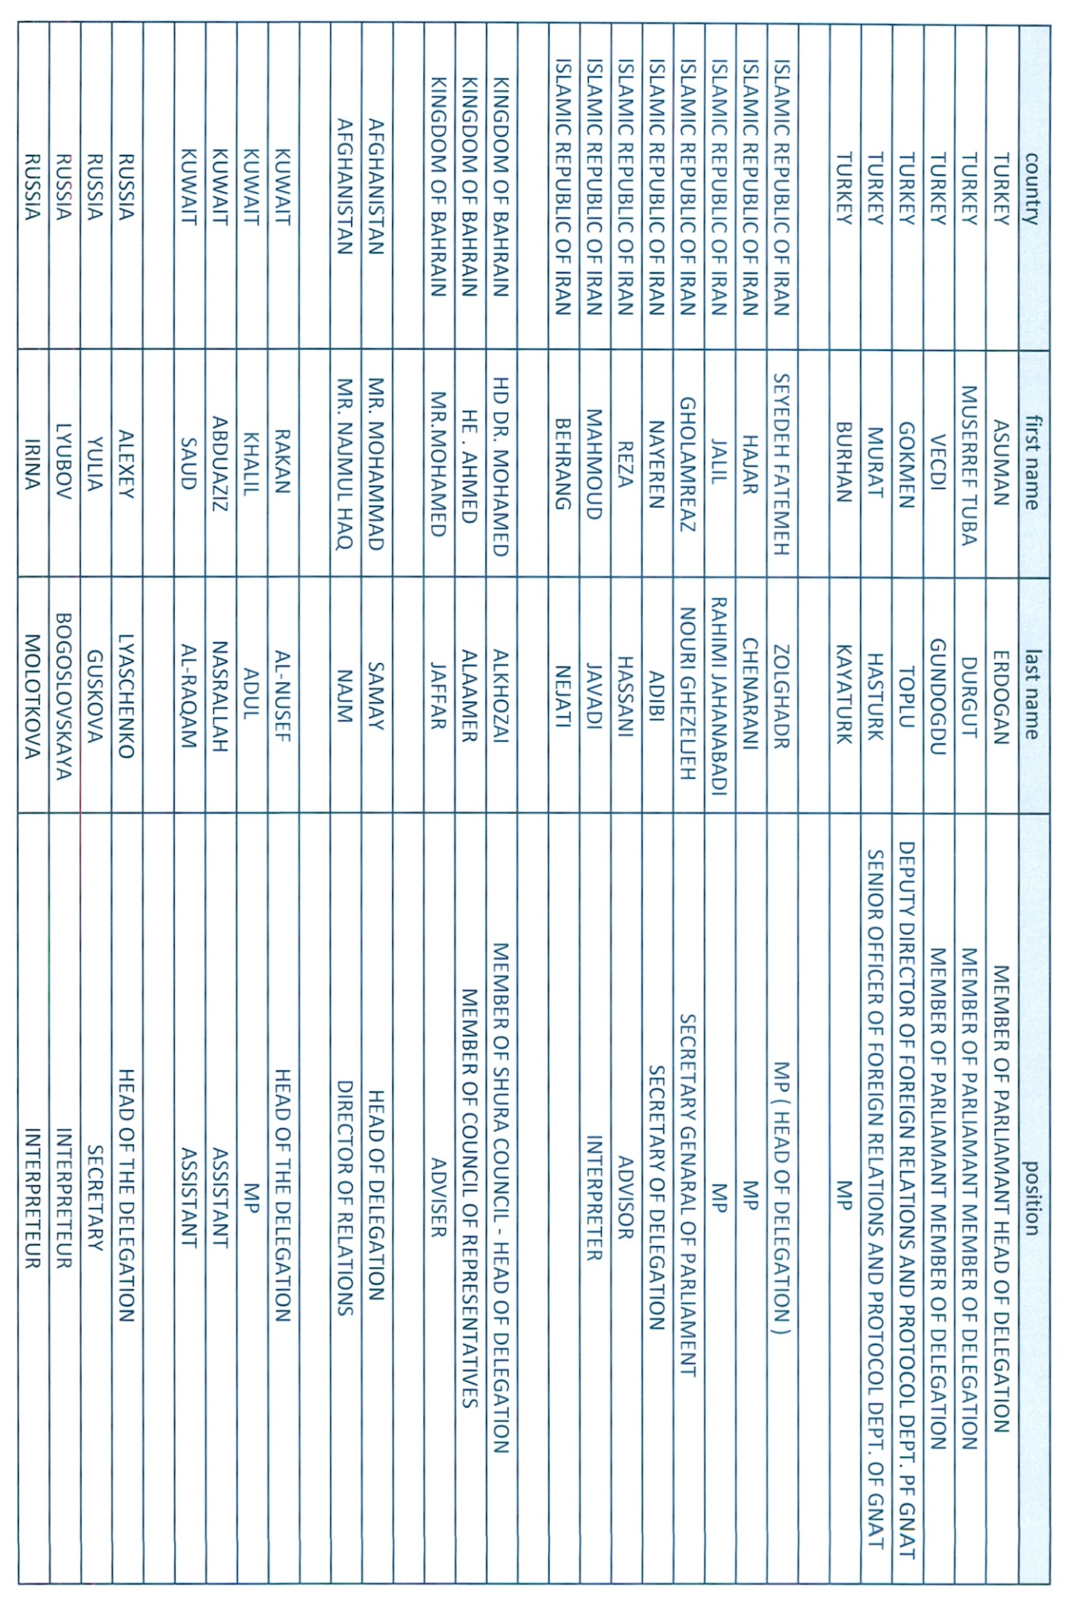

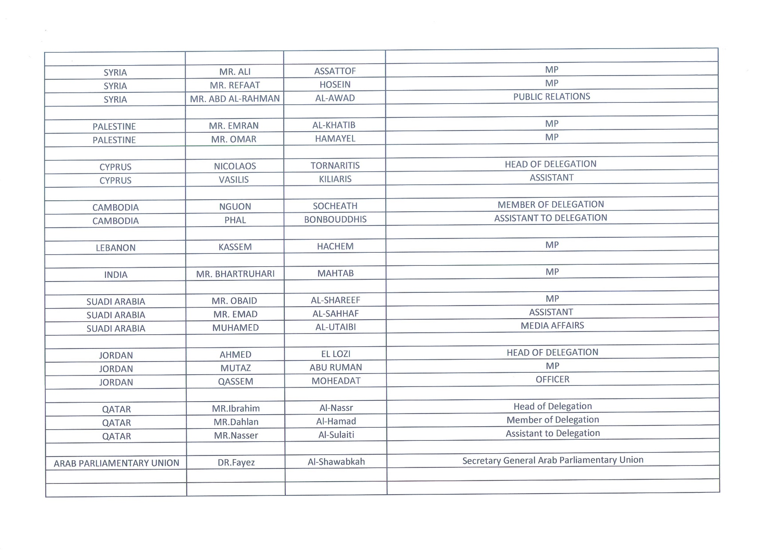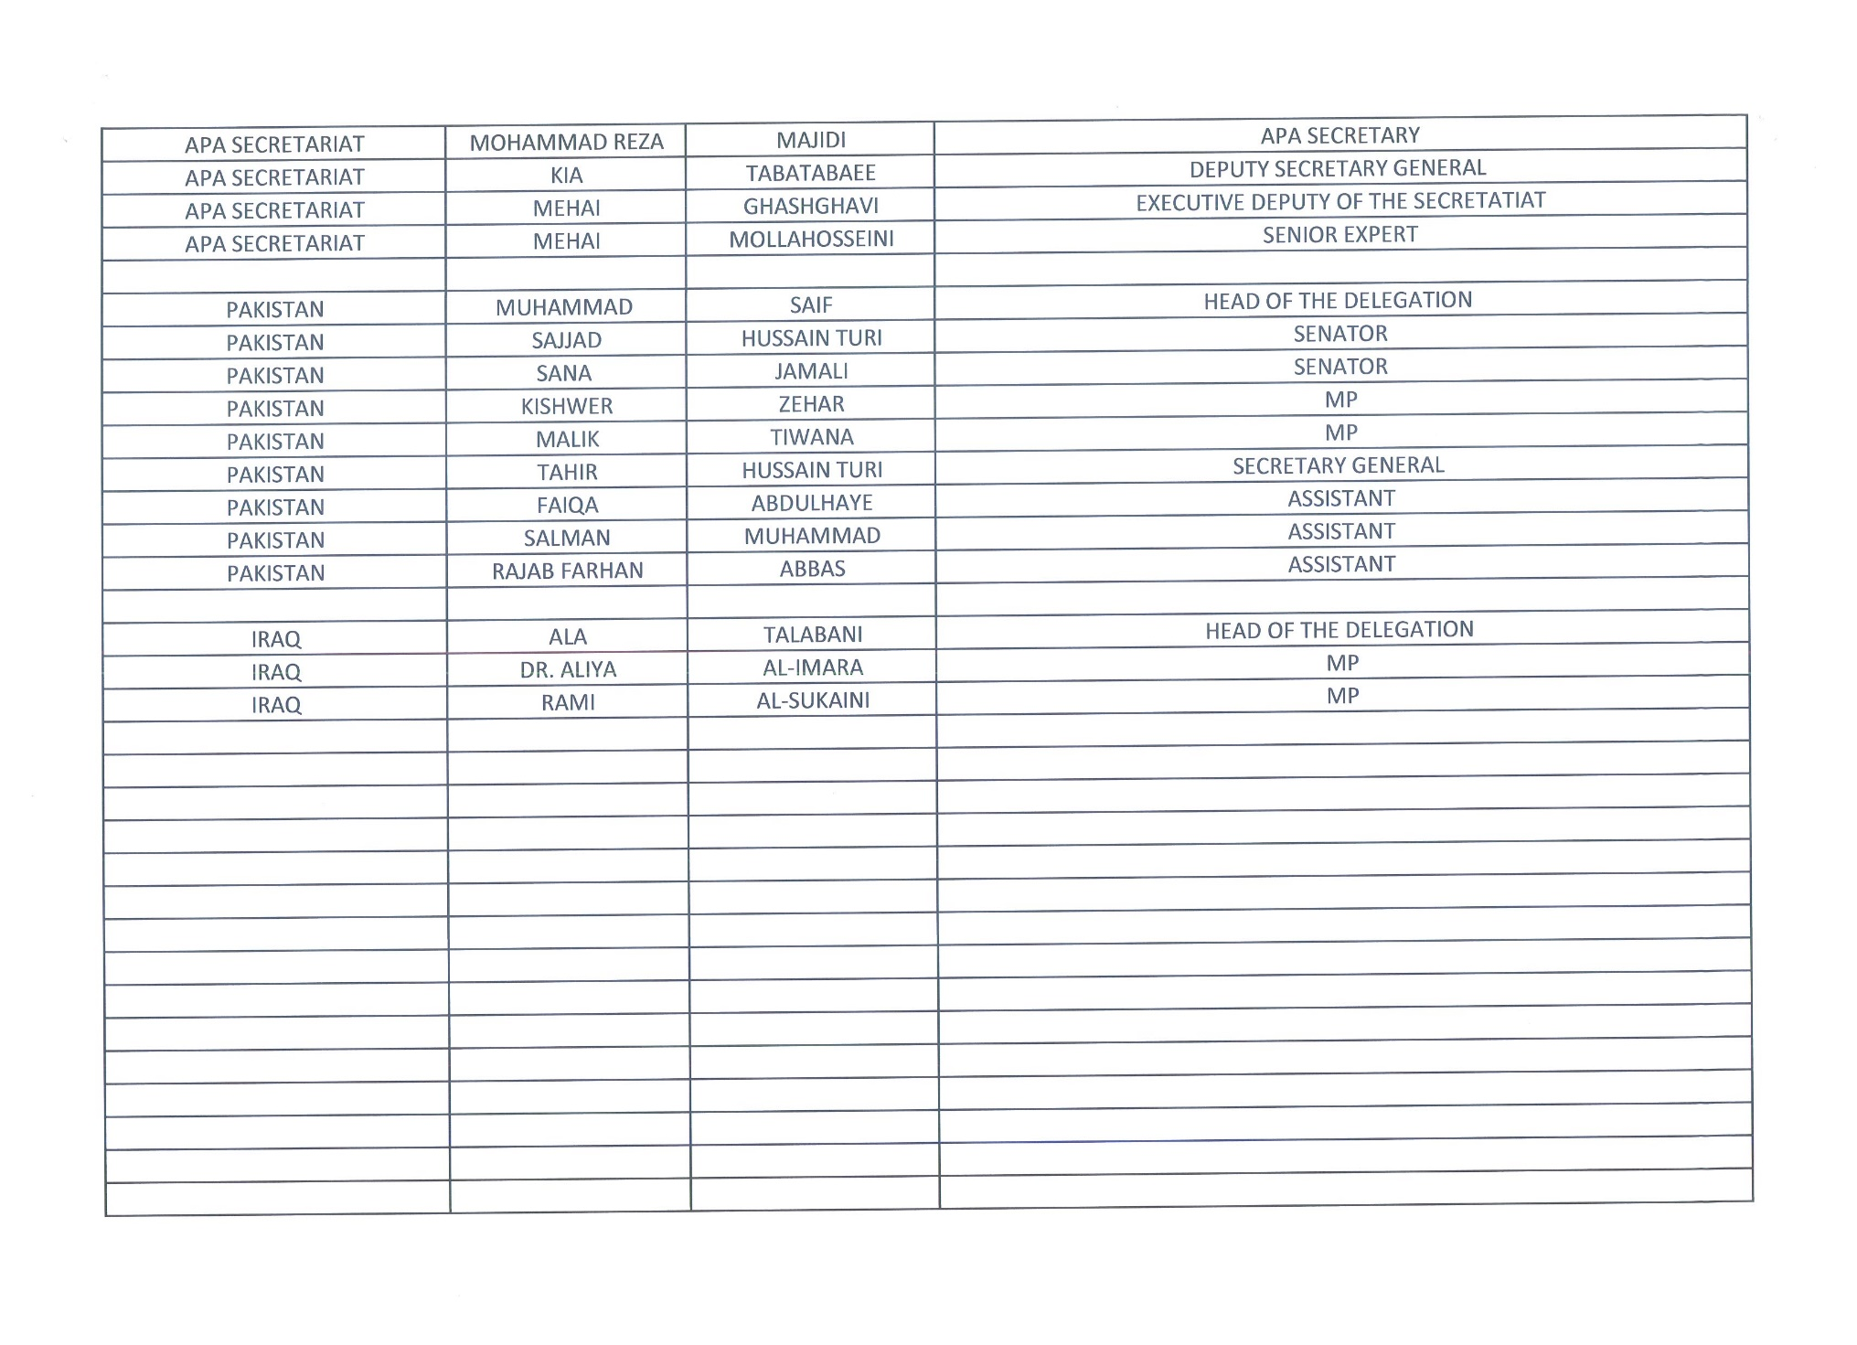

**Attachment II**

**His Excellency Mr. M. Halbousi's speech at the opening of the meeting of the APA Committee on Budget & Planning in Baghdad (3-5 September, 2019)**

Ladies and gentlemen, heads of participating delegations,

H.E. Mohammed Ali Al-Hakim, Minister of Foreign Affairs of Iraq,

His Excellency Mohammad Reza Majidi, Secretary General of the Asian Parliamentary Assembly,

H.E. Faiz Al Shawabkeh, Secretary General of the Arab Parliamentary Union,

Ladies and gentlemen members of participating delegations,

Excellencies, Heads of Diplomatic Missions,

Ladies and gentlemen,

It is an extraordinary day for Baghdad to embrace its brothers and friends, representatives of Asian parliaments in this meeting. In the name of the Presidency of ICOR and on behalf of the Iraqi people and its present representatives in ICOR and others, I thank you for coming and wish you a successful meeting.

Anyone who has already visited Baghdad will notice the great difference in quality of life and tangible development in various fields. Baghdad today is different and will be better tomorrow with the will of God and the determination of the Iraqi people.

There is no doubt that this positive progress did not come from a nothing, it reflects the will of the Iraqi people who resisted terrorism in its worst forms and dearly sacrificed, and finally raised the banner of victory. It is a story the details of which have not yet been told about people who have been subjected to the most severe tragedies that a society has ever suffered, Tragedies and sufferance that are beyond any ability of describing. ISIS was not only a terrorist organization, but a dark barbaric attack, in large numbers of individuals, heavily armed with lethal weapons who came from all over the world; to commit crimes of killing, captivating and intimidating people that has not yet recovered from wars, siege, isolation and hardship of life.

Nevertheless, our people triumphed by the will of their sons, all their sons, with the dignified religious Marj’iyas that stood behind them, the leaders of society and opinion, and the solidarity of their clans and constituents, the heroic militaries, the brave volunteers of the Popular - Tribal Mobilizations, Peshmerga, the courageous civilians who have continued the wheel of life despite the dangers, and with the help of regional and international friends that Iraqis will not forget their aid and support .

Needless to say that the victory over ISIS is a bright page in the lives of humanity, not only in the lives of Iraqis because terrorism did not target only Iraq- even if Iraq was the battlefield- but it targeted the whole region and all the countries of the world without exception.We are aware in Iraq that our war is not over yet. We still have problems that still need serious treatment, such as the displaced who are still, for various reasons, far from their liberated homes, the reconstruction of cities that have been totally or partially destroyed by the fighting, families of martyrs, women captivated by ISIS, the missing people , and the injured who fought the holy war against terrorism, and to deal with the social, psychological and intellectual effects of the period of terrorism, and many other files that we are still working on , day and night, as well as the sleeping cells of ISIS and the intellectual roots of extremism and terrorism.

We realize that most of these problems will be solved only through joint international efforts, and we expect from this session and its following related meetings to provide us with visions and mature projects concerning the priorities and programs that our countries need, especially since most of us are in similar circumstances.

One of the main problems facing our continent - the continent of Asia which is rich in resources and the diversity of its peoples and cultures - is the problem of external interventions and sharp polarizations through the policy of axes that spread in our regions and our countries.

We, in Iraq, believe that the policy of axes has vainly drained and will drain the resources of our peoples and spread hatred among our societies. That is why we have committed ourselves to a clear strategy that we do not hesitate to declare again and again and we expect all our friends to understand. We are committed to distance ourselves from any military conflicts and political axes of a controversial nature, and we will be a bridge to link all parties, in order to defuse the crises and bring closer the different points of views. We have paid more than enough for the conflicts of others in our country and region.

We will not allow ourselves to be a part of international conflicts, and therefore you find us constantly call for solving regional and international problems by peaceful means. Our People have tasted the scourge of successive wars; they are more aware of the grace of peace, and Iraq is establishing its strategic partnerships and common interests with all parties without being concerned about taking one side or the other. It is therefore not surprising that Iraq has recently become a center for regional security, hosting conferences, witnessing visits and intensive meetings, such as this blessed meeting. All these activities are a shining proof of an Iraq born again from under the rubble of wars, crises and terrorism with unrelenting will and unwavering determination.

Finally, I reiterate my thanks for your presence in our country

Peace, mercy and blessings of God be upon you

**Attachment III**



**Opening Remarks**

**by His Excellency Dr. Mohammad Reza Majidi**

**Secretary General of the Asian Parliamentary Assembly**

**September 3-5, 2019**

**Baghdad–Republic of Iraq**

**بسم الله الرحمن الرحیم**

**Madame Chair/ Mr. Chairman**

**Distinguished Delegates,**

**Ladies and Gentlemen,**

It is a great pleasure for me to have the privileges of addressing the august Meeting of APA Standing Committee on Budget and Planning. I also would like to take this great opportunity in my capacity as the APA Secretary General to sincerely welcome you, the honorable guests of the Council of Representatives of Iraq, for your presence here in the fascinating historical city of Baghdad;  the capital of brotherly Republic of Iraq.

On behalf of all the participating delegations and myself, I have the honor to express my heartfelt gratitude to H.E Mr. Muhammad Al- Halbosi, honorable Speaker of the Iraqi Council of Representatives, for his kind invitation extended to the APA Member Parliaments, and other high ranking officials of the Government and the Parliament of Iraq for their generous hospitality and excellent organization of our Meeting here at Royal Tulip Hotel of Baghdad.

 It is also an honor and privilege for the Asian Parliamentary Assembly to have the Republic of Iraq as one of the most dedicated and active members of its community to hosting one of the most important Standing Committees meeting at this crucial time in Baghdad.

**Madame Chair/Mr. Chairman**

Since this the first meeting of APA in Baghdad, I would like to use this valuable opportunity to brief our dear guests about the aims and activities of the APA.

First priority for Asian Parliamentary Assembly is the promotion of parliamentary diplomacy among Asian member parliaments. APA provides a forum to parliamentarians to exchange views, ideas and experiences for developing common strategies for the promotion of peace and sustainable development and humanitarian principles in Asia and all around the world.

In this forum, while issues of common interests are frequently raised, discussed and decided upon, major regional and global issues affecting the living standards of Asian continent are addressed too. Whatever sector of activity is embarked upon, we do our utmost efforts to safeguard and honor our Asian identity as our historically unify factor to be proud of.

We at APA, actively follow promotion of freedom, social justice, security and sharing access to up-to-date knowledge in various areas and promoting such knowledge among the member countries. Exploiting vast human natural resources and providing welfare facilities for the health and nutrition of its members' population, are also considered as the main issues in the agenda of our forum.

Madame Chair /Chairman

During all these years, we have been able to bring up the most important issue of planning of the Budget of the Permanent Secretariat of the APA, under the auspices of the chair of the committee from different parliaments who wholeheartedly tried to tackle the issues under deliberation. However, much remains to be done in this meeting of the Standing Committee.

 I am confident that under your able stewardship and sagacity as well as the leadership of the Council of Representatives of Iraq, APA will spare no efforts to take greater paces to achieve the objectives envisaged in its Charter.

 Madame Chair,

I would like to conclude by wishing you all fruitful and constructive deliberations during the session of the Standing Committee Meeting and wish you all a very pleasant time in beautiful city of Baghdad.

Thank you for your attention

**Attachment IV**

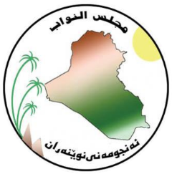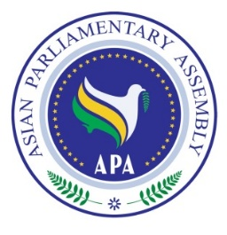

**The Meeting of APA Standing Committee on**

**Budget and Planning**

**3 - 5 September 2019**

**Baghdad, Iraq**

**Draft Agenda**

1- Adoption of the Agenda

2- Election of the Bureau

3- Opening Remarks by Chairperson

4- Report by APASecretary General

5- Consideration of:

* Draft Resolution on Planning APA Budget

6- Any other matters

As of 13 July 2019

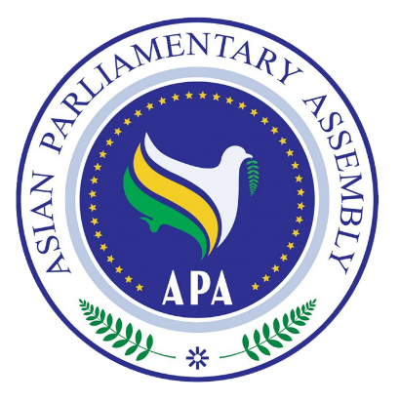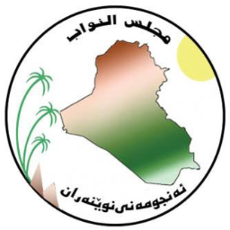**ASIAN PARLIAMENTARY ASSEMBLY (APA)**

**The Meeting of APA Standing Committee on**

**Budget and Planning**

**Royal Tulip Hotel, Baghdad, Iraq**

**3 - 5 September 2019**

**Tentative Program of Work**

|  |  |
| --- | --- |
| **Tuesday,3 September 2019** |  |
| All Day | Arrival of Delegations (Proceed to Royal Tulip Hotel)  Accommodation & Registration |
|  |  |
| 20:00 | Dinner Reception Buffet  *Venue:* Al Zahir Restaurant, Royal Tulip Hotel |
| **Wednesday,4 September2019** |  |
| 07:00 – 08:30 | Breakfast  *Venue:* Rayhana Restaurant, Royal Tulip Hotel |
| 08:30- 08: 45 | Arrival of delegations to the Meeting Hall  *Venue:* Royal TulipHotel |
| 09:00 – 10:00 | **Opening Ceremony**   * National Anthem  * Recitation from Holy Quran * Remarks by H.E. Muhammed Al Halbosi, Speaker of Iraqi Council of Representatives * Remarks by H.E. Mr. Sherko Merwes, Chairman of forign Relations Committee. * Remarks by H.E. Ms. Asuman Erdoğan, Rep. of APA President * Remarks by H.E. Dr. Mohammad Reza Majidi, APA Secretary General * Remarks by H.E. Ms. Ala Al-Talebani, Head of Delegation of Parliament of Iraq   *Venue:* Royal Tulip Hotel |
| 10:00 – 10:30 | Photo Session & Tea/Coffee Break |
| 10:30 – 13: 00 | **Meeting of the Standing Committee on Budget and Planning**  - Adoption of the Agenda  - Election of Bureau (Vice-Chair, Rapporteur)  - Opening remarks by the Chairman  - Report by the APA Secretary General  - Consideration of draft resolutions:   * Draft Resolution on Planning APA Budget. * Any other matters   *Venue:* Royal Tulip Hotel |
| 13:00 – 14:30 | Lunch  *Venue:* Rayhana Restaurant, Royal Tulip Hotel |
| 17:00 – 18:00 | Closing Session (Adoption of Final Report)  *Venue:* Royal Tulip Hotel |
| 20:30 | Dinner Reception host by H.E. The Speaker of Iraqi Council of Representatives  *Venue:* Al Zahir Restaurant, Royal Tulip Hotel |

|  |  |
| --- | --- |
| **Thursday, 5 September 2019** |  |
| 08:00 | Breakfast  *Venue:* Rayhana Restaurant, Royal Tulip Hotel |
| 09:00 | Visit the Iraqi National Museum |
| 11:00 | Visit Shopping Centre in Baghdad |
| 14:00 | Lunch  Venue: Al-Jadiriya Floating restaurant (The Ship) |
| 15:30 | Get back to Hotel |
| 18:00 | Religious Tour |
| 21:30 | Dinner Reception  *Venue:* Rayhana Restaurant, Royal Tulip Hotel |
|  |  |
| **Friday, 6 September 2019** |  |
| All Day | Departure of Delegations |

Edition: 2019-09-03

**Attachment V**



**ASIAN PARLIAMENTARY ASSEMBLY**

**The Meeting of APA Standing Committee on Budget and Planning**

**3-5 September 2019**

**Baghdad, Iraq**

**Report of the APA Secretary General**

Mr. Chairman,

Distinguished Delegate,

Dear Colleagues,

I have the pleasure to address this important meeting as Secretary General of the APA, presenting a report on the latest activities of our Standing Committee on Budget and planning.

Before I begin, allow me to once again take this opportunity to express, on behalf of myself and my colleagues in the APA Permanent Secretariat, my deepest appreciation to the Council of Representative of Iraq (مجلس النواب العراقی), state officials and most particularly H.E. Mr. Al-Halbousi, the honorable Speaker of the Council of Representative of Iraq, who took the burden of hosting our meeting through excellent organization and unique hospitality at the magnificent city of Baghdad, the capital of the Republic of Iraq.

**Excellencies,**

Let me brief you on the latest decisions and consecutive developments regarding the issues of planning budget of the APA Permanent Secretariat, under supervision of this Committee:

1-The very important issue of promoting the international status of the APA Permanent Secretariat and establishing financial and staff regulations for the Secretariat, was raised for the first time in November 2008 in Jakarta by the resolution on APA Budget and Expenditure (APA/Res/2008/0429) and in June 2014, the APA Secretary General presented the first draft of APA Staff and Financial Regulation to the Ad-hoc Committee on Financial and Staff Regulations in Cambodia.

2- The Ad-hoc Committee approved the draft resolution on Financial and Staff Regulations (Ad-hoc/Draft Res/ 2014 /09) and its attachment, and proposed it to the Executive Council for adoption. Consequently, in December 2014, the 7th APA Plenary in Lahore, Pakistan, approved the Financial and Staff Regulations.

3- The main objective of the approved resolution and its attachments was to prepare regulations to fit APA administrative needs to better suit its activities. It was realized that the most relevant international organization to the APA is Inter Parliamentary Union (IPU) and all APA Member Parliaments are familiar with its functions and rules. Therefore, the IPU’s system of scaling assessed contributions has been evaluated as a relevant and useful model for APA.

4-The Standing Committee on Staff and Financial Regulations in September 2016, in Kingdom of Cambodia, request all APA Member Parliaments to take required measures to secure budgetary resources required for the payment of their assessed contributions in accordance with the APA Staff and Financial Regulations approved by the 7th APA Plenary in Lahore, Pakistan. The resolution also encourage all APA Member Parliaments, particularly those with stronger economies to make voluntary financial contributions to the APA for the implementation of its resolutions.

5-But at the 9th APA plenary meeting in Cambodia, in December 2016, new proposals were made by different delegations on necessity of further clarification on measures of assessed contribution, terms and modalities of contribution, framework voluntary contribution and some suggestions on studying the budgetary models of other International organizations and tasked Abu Dhabi meeting of Standing Committee to follow this issue.

6- In May 2017, at the Standing Committee on Staff and Financial Regulations in Abu Dhabi, after a long discussion on the model of payment of contributions, out of 15 delegations that were present, 7 went in favor of equality of payment, 3 in favor of GDP & IPU system of payment and 5 with no views. Therefore, the Standing Committee requested the Executive Council to direct the Permanent Secretariat to communicate with all members to state their choice on how the APA should calculate the contribution; either by contributing equally or based on the percentage of the GDP.

7- The APA Secretariat in November 2018 in Istanbul, reported that upon the instruction of the Executive Council in Phnom Penh on October 2017, APA Secretary-General communicated with all APA Member Parliaments on 8 October 2017, and offered three Models of Payment:

A. The Model of Payment based on GDP of each Member Parliament.

B. The Model of Payment based on Equality.

C. The Model of Payment based on mixture of GDP and Equality. In this Model, every Member Parliament pays for example $20,000.00 as the equal contribution and additional amount, if necessary, is payable based on Member’s GDP.

At this meeting, the Secretariat stated that it seems the third Model means mixture of two Models of Equality and GDP can satisfy every Member Parliaments.

8- Consequently, the 11th Plenary at Istanbul adopted the following model of payment:

“Every APA Member Parliament will pay equally 20000 USD per year and extra budget will be taken into account on the basis of GDP…”.

9- In order to implement the decision of the APA 11th Plenary, APA Secretary General has sent a letter in December 2018, to all member parliaments and informed them that during the APA Eleventh Plenary in Istanbul, the Model of Payment of Assessed Contribution was unanimously adopted and requested them to include this amount of contribution in their respective parliament’s yearly budget.

10- Ever since, (December 2018) theSecretariat has only received replies from 4 parliaments namely: India, Turkey, Pakistan and Saudi Aribia in this regard.

**Excellencies,**

We had a long journey from 2008, and I should appreciate the efforts and endeavours of all distinguished APA member parliaments who tried their best to promote the international status of the APA Permanent Secretariat by adopting the current model of payment for contribution to the APA Secretariat budget. Nevertheless, allow me, as your Secretary General and your servant, be more frank with you. The fact is, by implementation of this model of payment, the Permanent Secretariat could not even manage half of its Basic Budget. The APA Budget Estimate for the Permanent Secretariat for the year 2019 is around 900,000 USD. It means that, even if all active member parliaments pay their contribution based on the current adopted model of payment, the Secretariat could hardly survive. Therefore, I appeal to you to choose a pragmatic and constructive approach in your today’s deliberation and come up with a more feasible formula for model of payments.

**Dear Colleagues,**

I would like to conclude by wishing you all a very fruitful and constructive discussion during the Standing Committee Meeting and deliberating on the draft resolution on Planning APA Budget.

Finally yet importantly, our appreciation and thanks goes to the Islamic Parliament of Iran for their generosity and support to the APA Secretariat since 2007.

Thank you very much.